**CENWP-OD-B 17 July 2024**

**MEMORANDUM FOR THE RECORD**

**SUBJECT: 24BON033 MFR AFF Sockeye, Juvenile Chinook, and Adult Pacific Lamprey Mortalities**

On the morning of 17 July 2024, CRITFC biologists notified Project Biologists of one Sockeye, one Juvenile Chinook, and one Adult Pacific Lamprey mortality within the Adult Fish Facility (AFF). Each fish was scanned for PIT tags, measured, inspected, and returned to the river. While no fish was found to have a PIT tag, the juvenile Chinook did have an orange elastomer tag.

1.

1. Species – Sockeye Salmon (*Oncorhynchus nerka*)
2. Origin – Unknown
3. Length – 48.26cm
4. Marks and tags – None
5. Marks and Injuries found on carcass – Upper half of caudal fin missing.
6. Cause and Time of Death – Unknown
7. Future and Preventative Measures – N/A

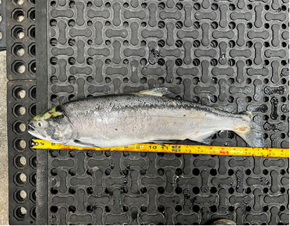

2.

A. Species – Pacific Lamprey (*Entosphenus tridentatus*)

B. Origin – Unknown

C. Length – 71.76cm

D. Marks and tags – None

E. Marks and Injuries found on carcass – None

F. Cause and Time of Death – Unknown

G. Future and Preventative Measures – N/A

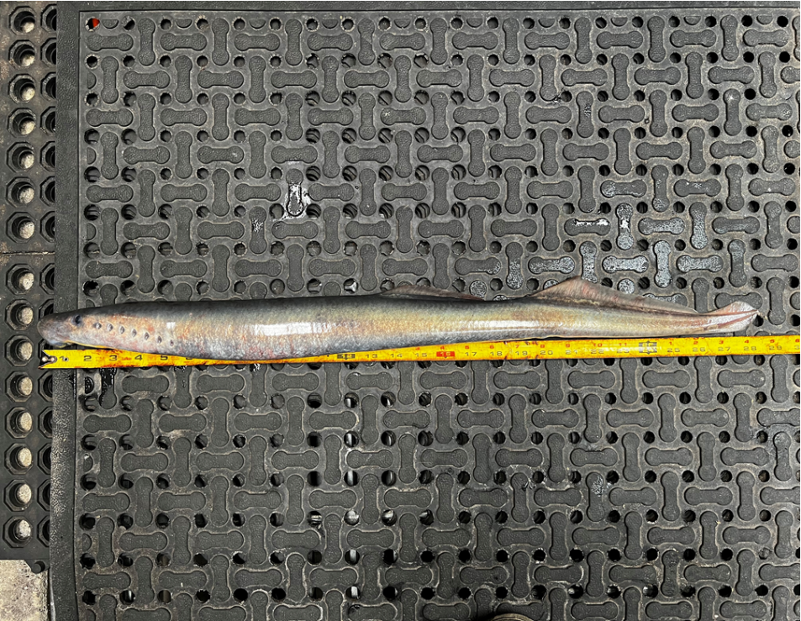

3. A. Species – Chinook Salmon (juvenile) (*Oncorhynchus tshawytscha*)

B. Origin – Unknown

C. Length – 27.94cm

D. Marks and tags – Orange elastomer tag in right eye.

E. Marks and Injuries found on carcass – Large hold on the side potentially due to lamprey bite

F. Cause and Time of Death – Unknown

G. Future and Preventative Measures –N/A

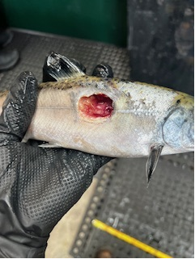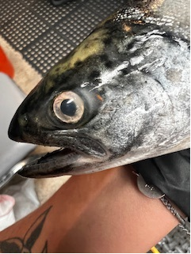

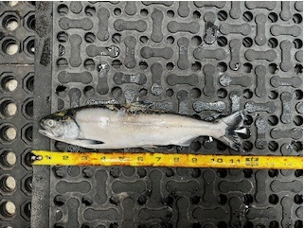

Sincerely,

Project Fisheries